

Tech Saksham

Case Study Report

Data Analytics with Power BI **“360 DEREE BUSINESS ANALYSIS OF ZOMATO ONLINE DELIVERY**

# APP USING POWERBI”

**“THIRUVALLUVAR COLLEGE”**

|  |  |
| --- | --- |
| **NM ID** | **NAME** |
| E19B58B058694E1B2B84B8E1354060E2 | MOHAMMED SAMEER S |

TRAINER NAME:R.UMAMAHESWAI MASTER TRAINER:R.UMAMAHESWARI

# ABSTRACT

Using Power BI for an online food delivery app like Zomato can provide valuable insights into various aspects of the business, such as sales performance, customer behavior, and operational efficiency. By leveraging Power BI for data analysis and visualization, Zomato can make data-driven decisions to improve customer satisfaction, increase sales, and optimize operations.

## INDEX

|  |  |  |
| --- | --- | --- |
| **Sr. No.** | **Table of Contents** | **Page No.** |
| 1 | Chapter 1: Introduction | 4 |
| 2 | Chapter 2: Services and Tools Required | 7 |
| 3 | Chapter 3: Project Architecture | 8 |
| 4 | Chapter 4: Modeling and Result | 10 |
| 5 | Conclusion | 13 |
| 6 | Future Scope | 14 |
| 7 | Links | 15 |
|  |  |  |

**CHAPTER 1 INTRODUCTION**

#### Problem Statement

"Zomato, a leading online food delivery platform, aims to enhance its user experience, optimize operational efficiency, and drive revenue growth. However, it faces challenges such as inconsistent delivery times, varying food quality across restaurants, and high customer churn rates. Additionally, there is a need to improve restaurant partner satisfaction and streamline inventory management.

The objective is to leverage data analytics and technology solutions to address these challenges and establish Zomato as the preferred choice for both customers and restaurant partners in the highly competitive online food delivery market."

#### Proposed Solution

Certainly! Here's a proposed solution using Power BI for Zomato:

#### Real-time Dashboard for Order Tracking:

* + Develop a real-time dashboard in Power BI to track incoming orders, order status (placed, confirmed, out for delivery, delivered), and delivery times.

#### Performance Analytics for Restaurants:

* + Create dashboards to analyze the performance of restaurants partnered with Zomato, including order volume, revenue generated, average order value, and customer ratings.

#### Customer Behavior Analysis:

* + Utilize Power BI to analyze customer behavior, such as order frequency, preferred cuisine types, average spend, and satisfaction scores.

#### Delivery Optimization:

* + Analyze delivery times and optimize delivery routes using Power BI's geographical visualization capabilities.

#### Quality Control and Feedback Management:

* + Monitor customer feedback and ratings for each order and restaurant.
  + Set up alerts in Power BI to notify management of any significant decrease in ratings or negative trends.

#### Inventory Management:

* + Develop inventory management dashboards to track ingredient usage and stock levels at restaurants.

By implementing these solutions using Power BI, Zomato can enhance its operational efficiency, improve customer satisfaction, and strengthen its position in the competitive online food delivery market.

#### Feature

* **Real-Time Analysis**: The dashboard will provide real-time analysis of customer data.
* **Customer Segmentation**: It will segment customers based on Raing For Delivery Food ,etc
* **Trend Analysis**: The dashboard will identify and display trends in customer behavior.
* **Predictive Analysis**: It will use historical data to predict future customer behavior.

#### Advantages

Using Power BI for an online food delivery app like Zomato offers several advantages:

#### Data Visualization:

Power BI provides powerful visualization tools to represent data in various formats such as charts, graphs, and maps. This makes it easier for Zomato to understand complex data patterns and trends, facilitating quicker decision-making.

#### Real-time Insights:

With Power BI's ability to connect to real-time data sources, Zomato can access up-to-date information on order volumes, delivery times, and customer feedback. This enables them to make timely adjustments to their operations and improve overall efficiency.

#### Customizable Dashboards:

Power BI allows Zomato to create customized dashboards tailored to their specific needs and requirements. They can easily design dashboards to track key performance indicators (KPIs), monitor sales metrics, and analyze customer behavior, providing a comprehensive view of their business operations.

#### Integration with Multiple Data Sources:

Power BI seamlessly integrates with various data sources, including databases, cloud services, and APIs. This enables Zomato to consolidate data from multiple sources such as sales transactions, customer reviews, and delivery logs into a single, unified platform for analysis.

#### Advanced Analytics:

Power BI offers advanced analytics capabilities, including predictive analytics and machine learning, which Zomato can leverage to forecast demand, identify trends, and make data-driven predictions about customer behavior and preferences.

of all sizes, including startups like Zomato, to leverage powerful analytics tools without significant upfront investment.

Overall, Power BI provides Zomato with a comprehensive analytics platform to gain valuable insights, optimize operations, and drive growth in the competitive online food delivery market.

* 1. **Scope**

### The scope of Power BI in an online food delivery app like Zomato is extensive and covers various aspects of the business, including:

1. **Sales and Revenue Analysis:**

### Power BI can be used to track and analyze sales data, including total orders, revenue generated, average order value, and sales trends over time. This helps Zomato understand its financial performance and identify opportunities for revenue growth.

1. **Customer Behavior Analysis:**

Power BI enables Zomato to analyze customer behavior, such as order frequency, preferred cuisines, popular dishes, and customer satisfaction scores. This information helps Zomato personalize marketing efforts, improve customer retention, and enhance the overall user experience.

## CHAPTER 2

**SERVICES AND TOOLS REQUIRED**

#### Services Used

* + - **Data Collection and Storage Services:** Develop a real-time dashboard in Power BI to track incoming orders, order status (placed, confirmed, out for delivery, delivered), and delivery times.
    - **Data Processing Services**: The dashboard will provide real-time analysis of customer data.
    - **Machine Learning Services** : It will use historical data to predict future customer behavior.

#### Tools and Software used Tools:

* + - **PowerBI**: The main tool for this project is PowerBI, which will be used to create interactive dashboards for real-time data visualization.
    - **Power Query**: This is a data connection technology that enables you to discover, connect, combine, and refine data across a wide variety of sources.

#### Software Requirements:

* + - **PowerBI Desktop**: This is a Windows application that you can use to create reports and publish them to PowerBI.
    - **PowerBI Service**: This is an online SaaS (Software as a Service) service that you use to publish reports, create new dashboards, and share insights.
    - **PowerBI Mobile**: This is a mobile application that you can use to access your reports and dashboards on the go.

## CHAPTER 3 PROJECT

**360 Degree Business Analysis Of Zomato Delivery App Using Power BI**

#### Zomato Delivery App:

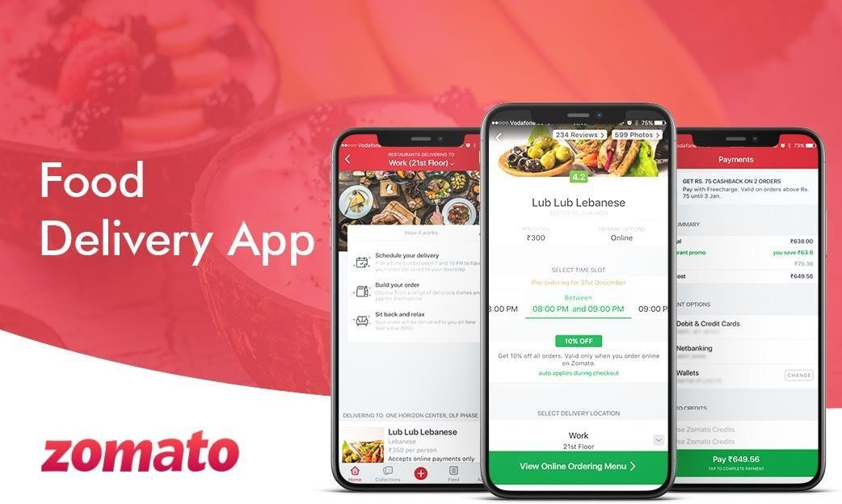

* + 1. **Data Collection**: The Data of Develop a real-time dashboard in Power BI to track incoming orders, order status (placed, confirmed, out for delivery, delivered), and delivery times.
    2. **Data Storage**: The collected data is stored in a database for processing. Azure SQL Database or AWS RDS can be used for this purpose.
    3. **Data Processing**: The stored data is processed in real-time using services like Azure Stream Analytics or AWS Kinesis Data Analytics.
    4. **Machine Learning**: Predictive models are built based on processed data using Azure Machine Learning or AWS SageMaker. These models can help in predicting customer behavior, detecting fraud, etc.
    5. **Data Visualization**: The processed data and the results from the predictive models are visualized in real-time using PowerBI. PowerBI allows you to create interactive dashboards that can provide valuable insights into the data.
    6. **Data Access**: The dashboards created in PowerBI can be accessed through PowerBI Desktop, PowerBI Service (online), and PowerBI Mobile.



By implementing these solutions using Power BI, Zomato can enhance its



operational efficiency, improve customer satisfaction, and strengthen its position



in the competitive online food delivery market.

## CHAPTER 4 MODELING AND RESULT

**Manage relationship**

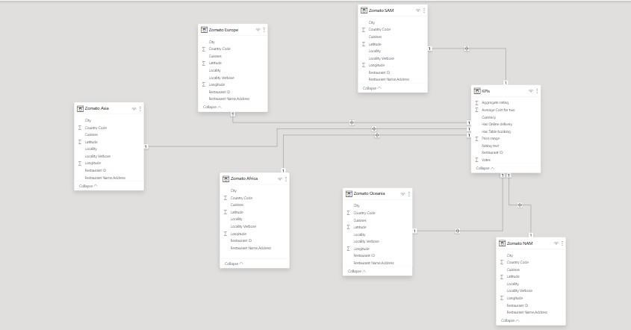The “disp” file will be used as the main connector as it contains most key identifier (account id, client id and disp id) which can be use to relates the 7 data files together. The “district” file is use to link the client profile geographically with “district id”



**Dashboard:**

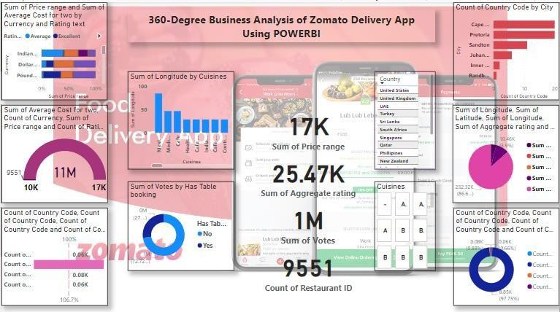

## CONCLUSION

In conclusion, implementing Power BI within Zomato's online food delivery app offers a comprehensive solution to address key challenges and capitalize on opportunities in the rapidly evolving food delivery market. By leveraging Power BI's advanced analytics capabilities, Zomato can:

1. Gain actionable insights into sales performance, customer behavior, and operational efficiency.
2. Optimize resource allocation, streamline operations, and enhance delivery service quality.
3. Personalize marketing efforts, improve customer retention, and drive revenue growth.
4. Strengthen partnerships with restaurants by providing data-driven support and incentives.
5. Monitor feedback and reviews in real-time, ensuring continuous improvement in service quality.
6. Forecast demand, predict market trends, and stay ahead of the competition.

Ultimately, the integration of Power BI empowers Zomato to make data-driven decisions, improve overall business performance, and maintain its position as a leader in the competitive online food delivery market. With Power BI's flexible and scalable platform, Zomato can adapt to evolving customer preferences and market dynamics, driving long-term success and sustainability.

## FUTURE SCOPE

The future scope of this project is vast. The future scope of Power BI in an online food delivery app like Zomato is extensive and covers various aspects of the business, Overall, the scope of Power BI in an online food delivery app like Zomato is broad and encompasses various aspects of the business, from sales and marketing to operations and customer service. By leveraging Power BI's powerful analytics capabilities, Zomato can gain valuable insights, make informed decisions, and drive business growth in the highly competitive food delivery market

## REFERENCE

**<https://www.youtube.com/live/kbe61N-qQ-s?si=olPJbhWkD6Mk1KsR>**